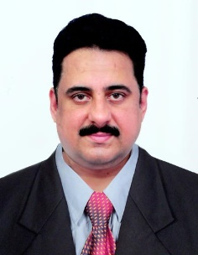
Name : Dr. S. Venkat Prasat
Department : Mechanical Engineering
College : Institute of Engineering & Technology
Contact Details :
E-mail Id: venkatprasat.cet@srinivasuniversity.edu.in
svenkatprasat@gmail.com
Mobile: 9942171745

Educational Details:
- UG : B.E. (Mechanical Engineering)
- PG : M.E. (CAD/CAM)
- Ph.D. : Ph.D. (Mechanical Engineering)

Teaching Experience : 24.5 years
Industrial Experience : 1.5 years
Research Experience : 14 years
Research Details:
- Research Area : Composite Materials, Tribology, Machining,
Materials Characterization & Robotics
- Funding sanctioned : Secured funds from AICTE for organizing FDP & STTP and has executed Consultancy project in Robotics.
- Publications : 38
- Conference/Workshops attended: 40
- Any other details : Presently working as a Professor and Unit Head (Robotics, Artificial Intelligence & Machine Learning), Department of Mechanical Engineering.
    - Google Scholar: Citations: 423, h-index: 7
    - Scopus: Citations: 213, h-index: 6

